Milestone 3

Group 13 -

Brayden Lingelbach

Nelig Fernando

Krish Patel

Noah Zhou

Cole Robert Bryant

Product Backlog

|  |  |  |  |  |  |
| --- | --- | --- | --- | --- | --- |
| **Order** | **ID** | **Item** | **Type** | **Status** | **Estimate** |
| **1** | The members should be able to access benefits from sponsors. | | | | |
|  | 111 | As an applicant, I want to create an account so that I can apply for DGA membership so I may receive benefits. | Functional | Done | 3 |
|  | 112 | As a member of the DGA, I want to access my current benefits package so that I may know what I am entitled to as a member. | Functional | Done | 3 |
| 113, | 113 | As a member of the DGA, I want to be able to request new benefits from my sponsor so I may reserve the right to request benefits. | Functional | Done | 5 |
|  | 114 | As a member, I want to be able to transfer my benefits from one sponsor to another, so they remain when I am required to change companies. | Functional | Not Started | 8 |
|  | 115 | As a member, I want to be able to delete my account from the database, so I may choose to join another organization. | Functional | Done | 2 |
| **2** | The sponsor should be able to recruit and manage members. | | | | |
|  | 121 | As a sponsor, I want to create an account so we may begin to manage the benefits of our members. | Functional | Done | 3 |
|  | 122 | As a sponsor of the DGA, I want to view a list of my current members within my company so that I may view/manage these members. | Functional | Done | 2 |
|  | 123 | As a sponsor, I want to be able to recruit members within the DGA who have not been assigned a sponsor so we can expand our company. | Functional | Not Started | 5 |
|  | 124 | As a sponsor, I want the ability to remove members from our sponsorship in necessary instances so that we may have control. | Functional | Done | 2 |
| **3** | Users should be able to access profile information including their email, username, phone number, and other user specific data. | | | | |
|  | 131 | As a user of the software, I would like to be able to quickly pull up profile information the system has stored on me. | Accessibility | Done | 5 |
|  | 132 | As a user I would like to be able to send my profile information to the production company. | Accessibility | Done | 2 |
|  | 133 | As a user I would like to be able to request my information sent to other sponsors, and users. | Functional | Done | 2 |
| **4** | A user should have easy access to help within the system such as customer support, and support forums. | | | | |
|  | 141 | As a user of the system, I would like customer support so I may receive help with my account if necessary. | Accessibility | Not Started | 3 |
|  | 142 | As a user I would like to be able to easily communicate with other users about issues that I'm having within the system. | Accessibility | Not Started | 5 |
| **5** | Sponsors should be able to manage the benefits of their members. | | | | |
|  | 151 | As a sponsor, I want to be able to add benefits to our list of members so they may receive their benefits. | Functional | Done | 3 |
|  | 152 | As a sponsor, I want to be able to remove benefits from members in the necessary instances where those plans aren’t feasible. | Functional | Done | 3 |
|  | 153 | As a sponsor, I want to have the ability to respond to requests for new plans so my members can remain satisfied with their sponsorship. | Functional | Not Started | 5 |
| **6** | The system’s web interface should be readable and accessible to all users. | | | | |
|  | 161 | As a user of the system, I want the website to have a readable UI, that way I can use the website more easily. | Accessibility | Not Started | 5 |
|  | 162 | As a user I would want quick response times from the system per my request | Performance | Not Started | 3 |
|  | 163 | As a sponsor, I want an intuitive management UI so that I can easily manage a large quantity of members. | Accessibility | Not Started<< | 8 |

Class Diagram

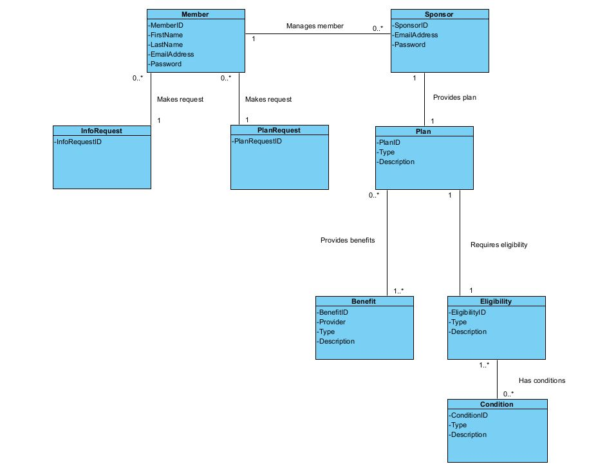

Activity Diagrams

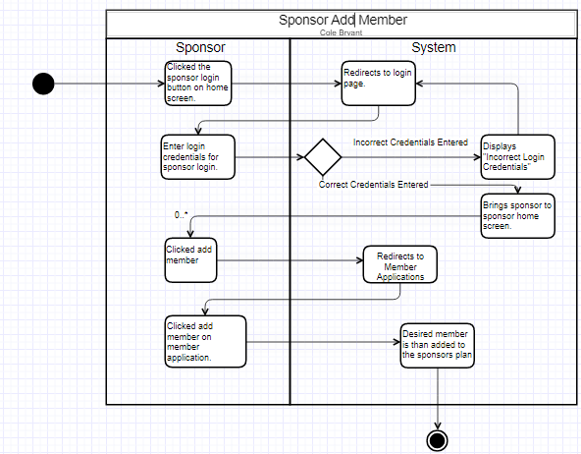

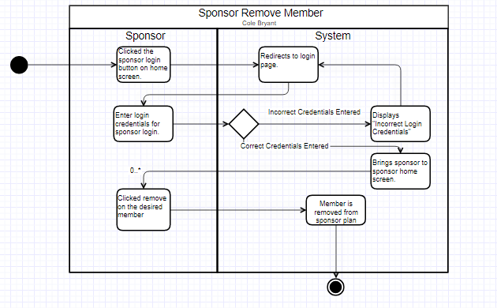

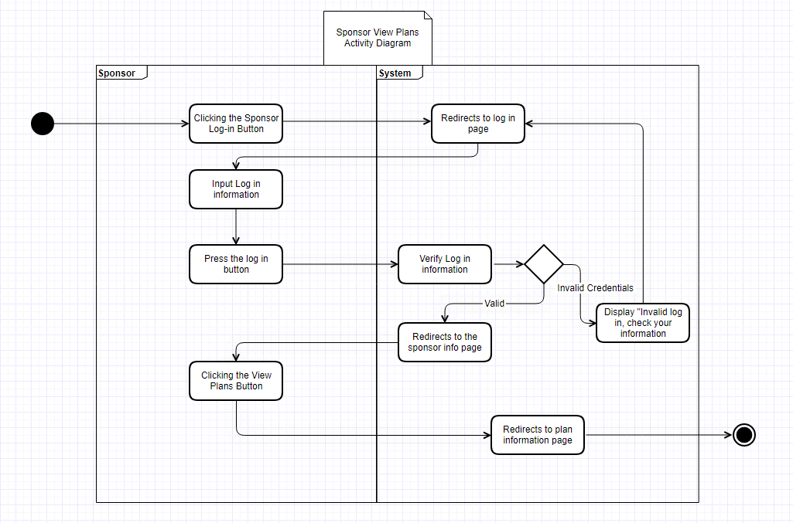

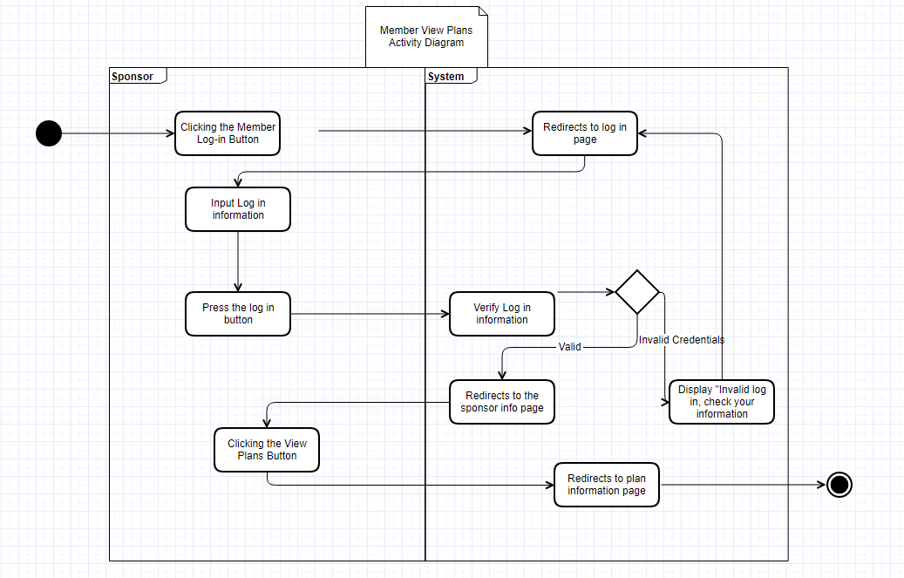

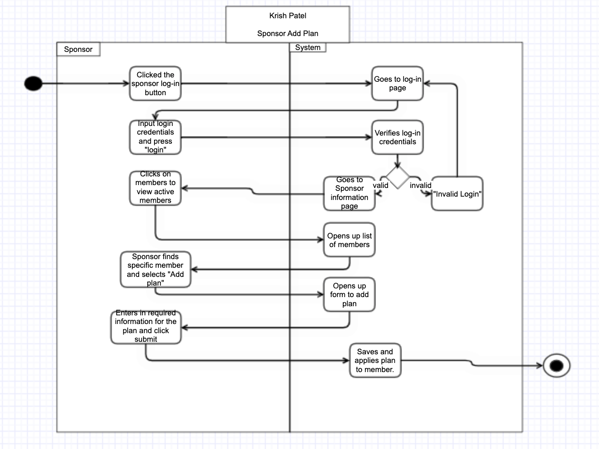

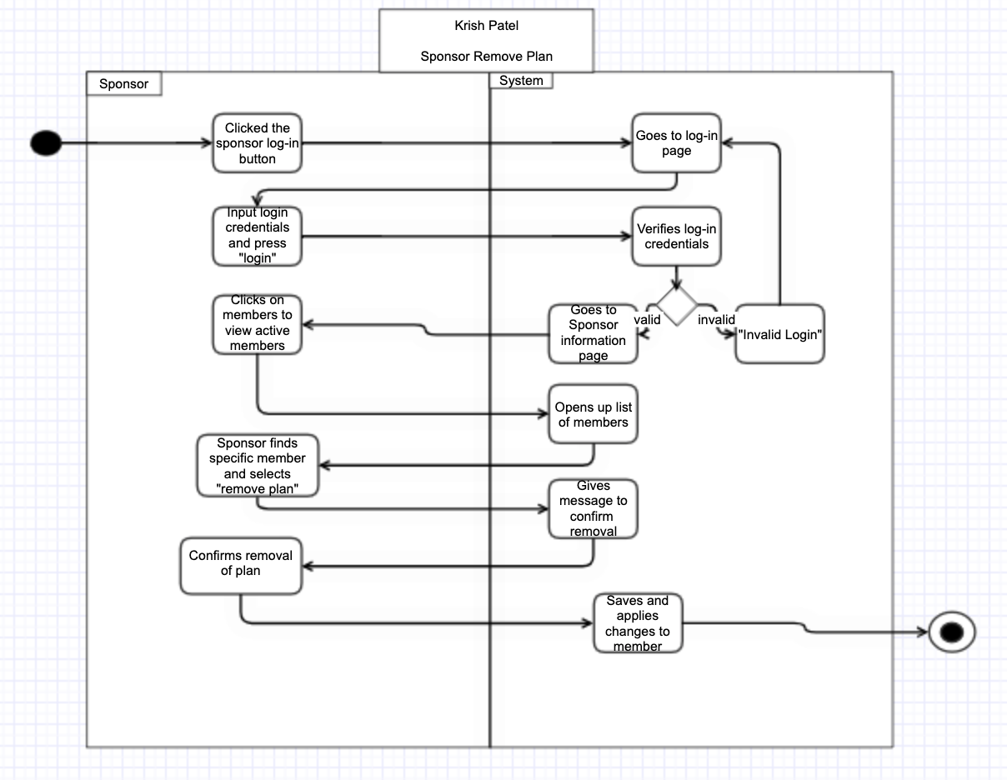

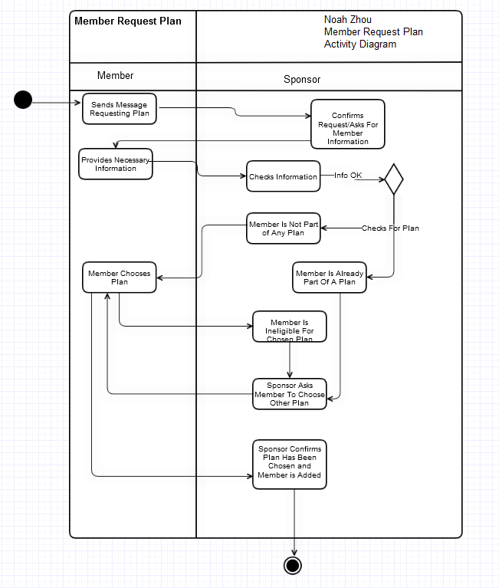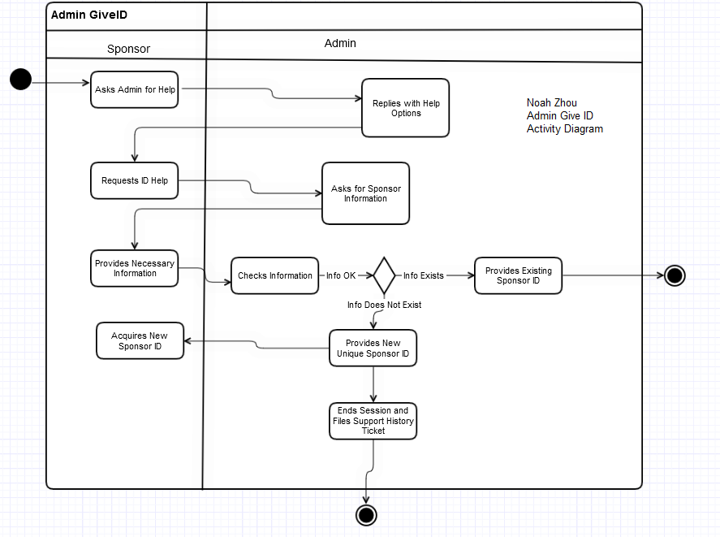

Brayden Lingelbach -

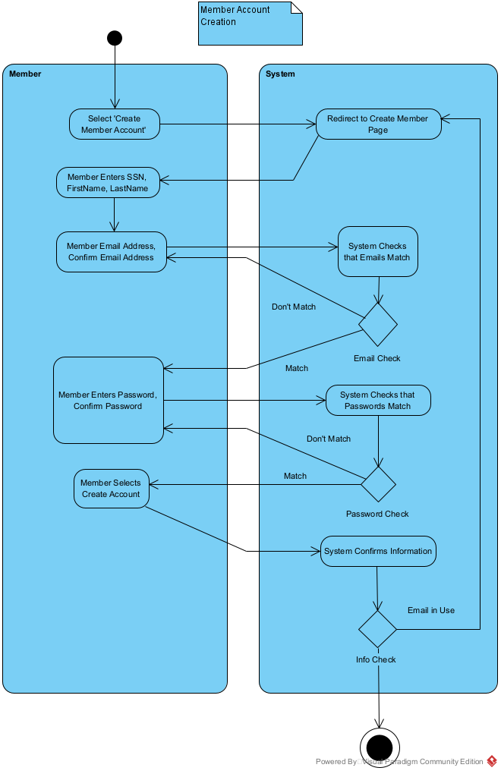

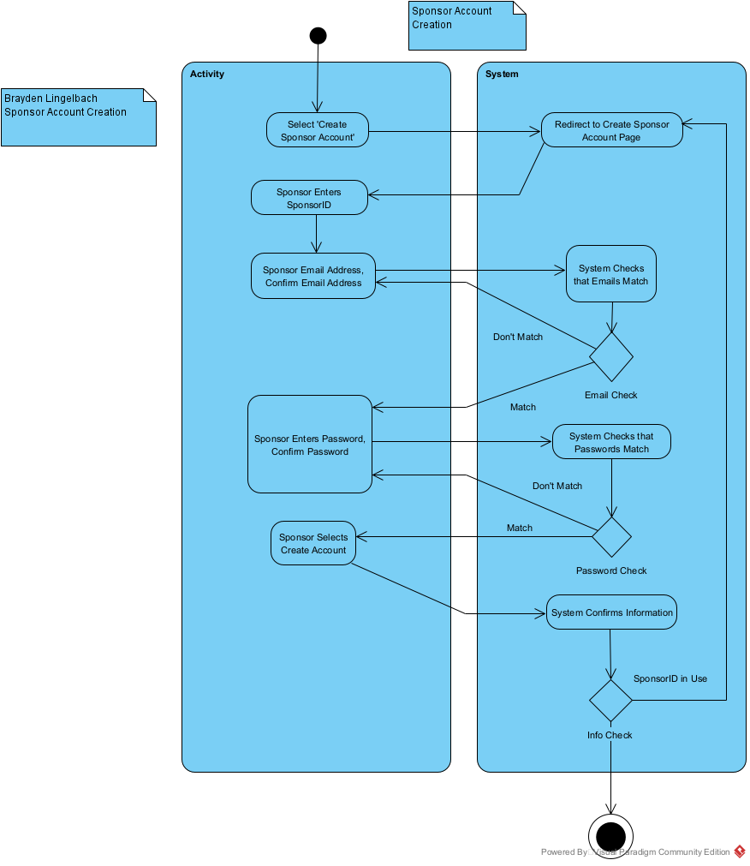

Sequence Diagram

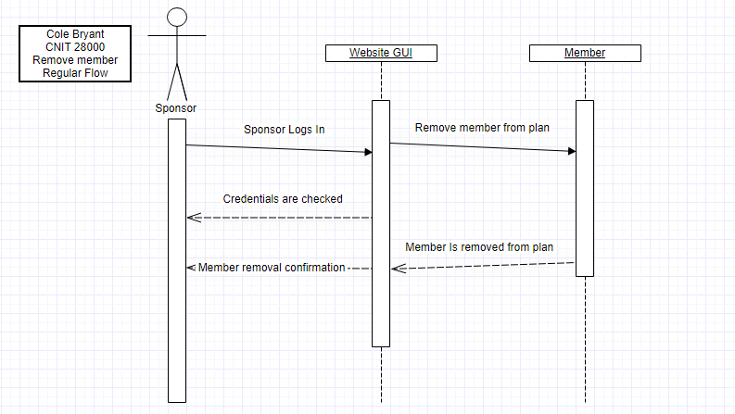

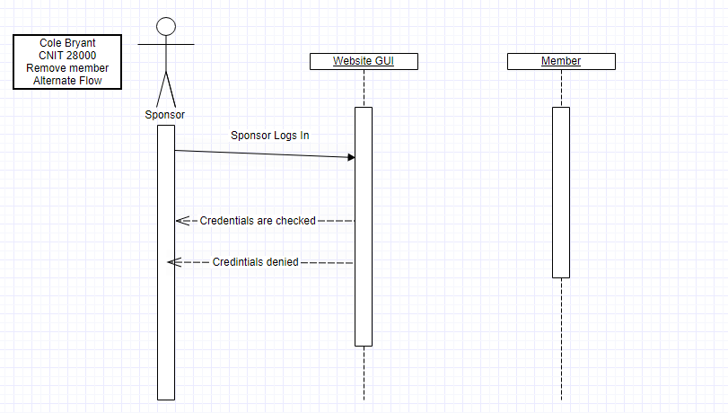

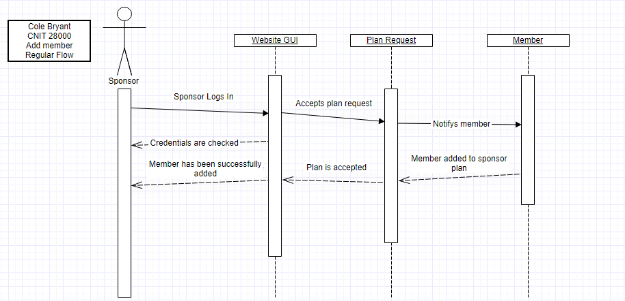  
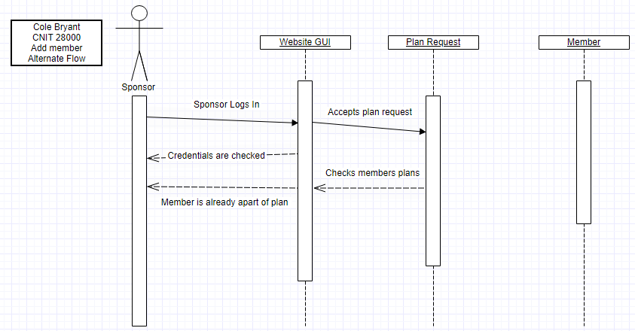

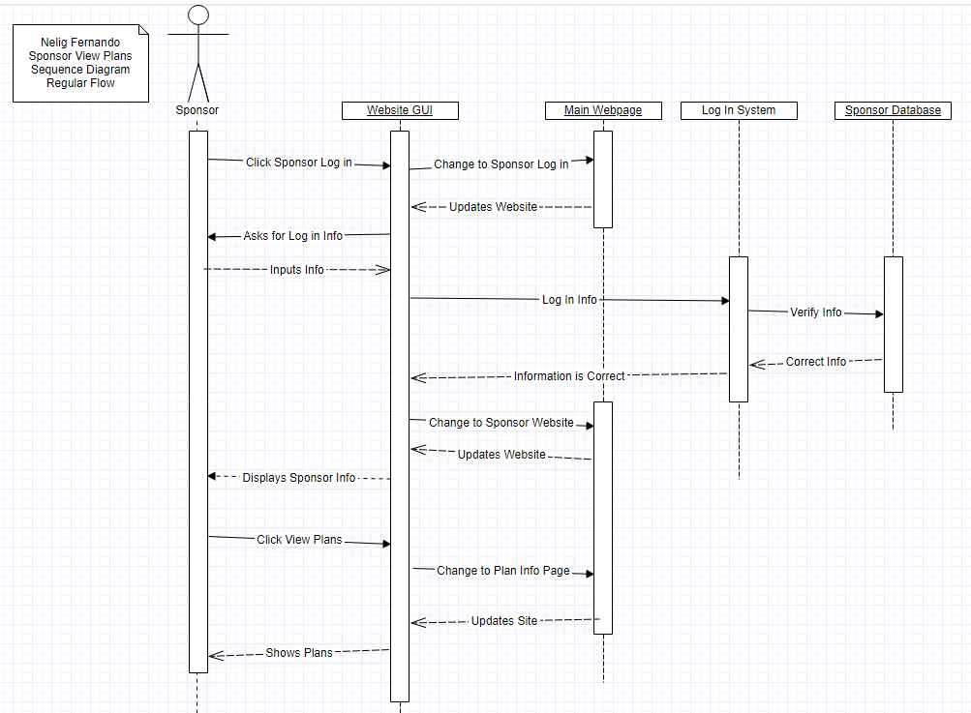

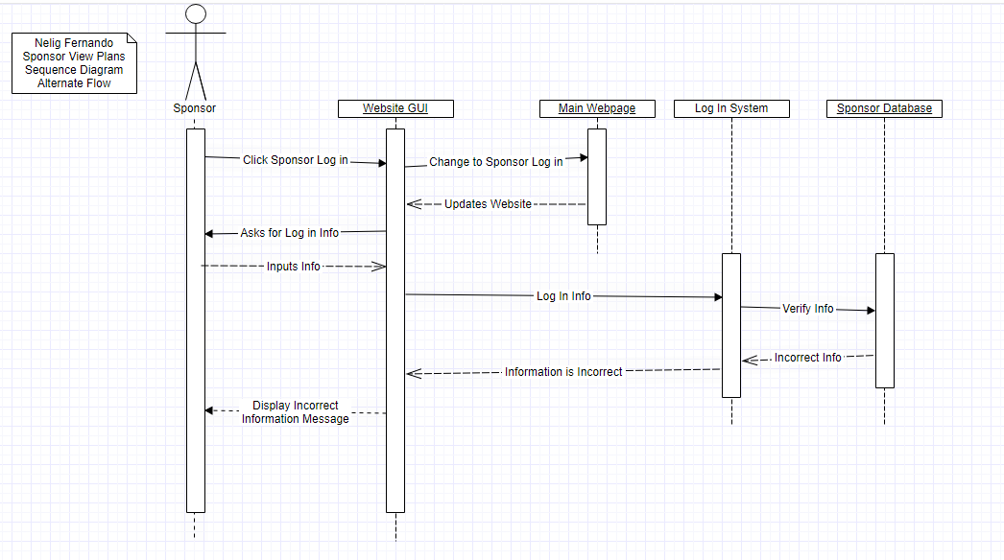

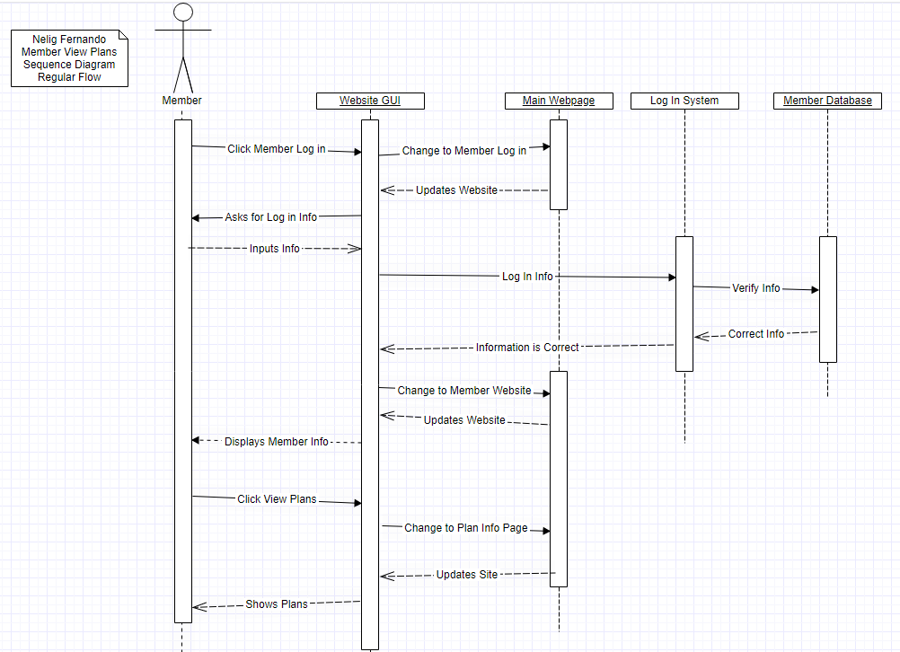

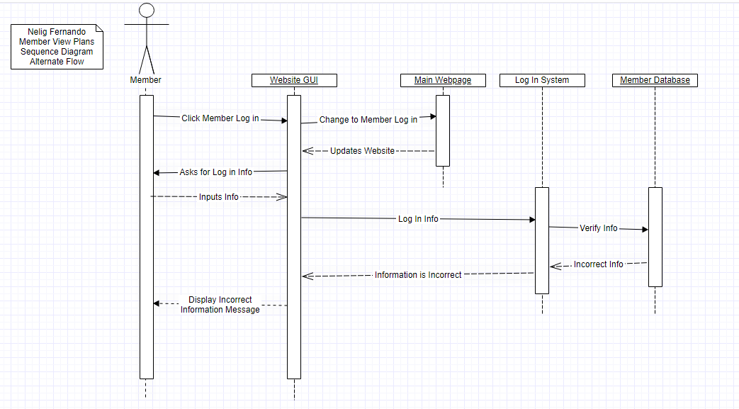

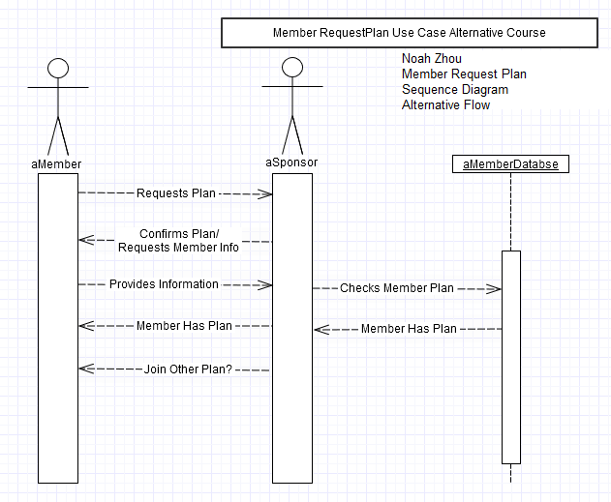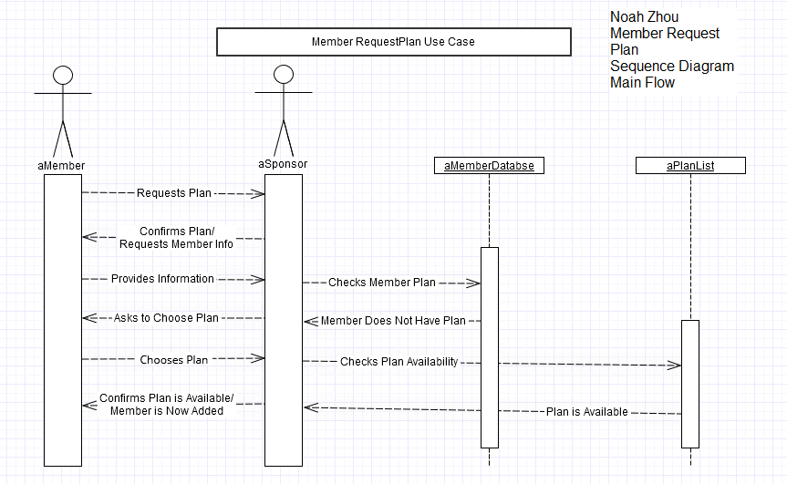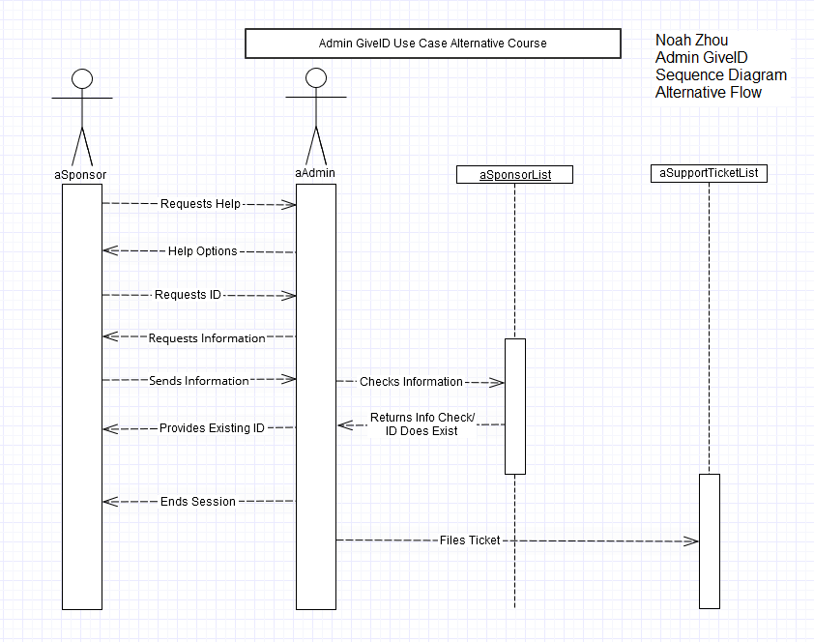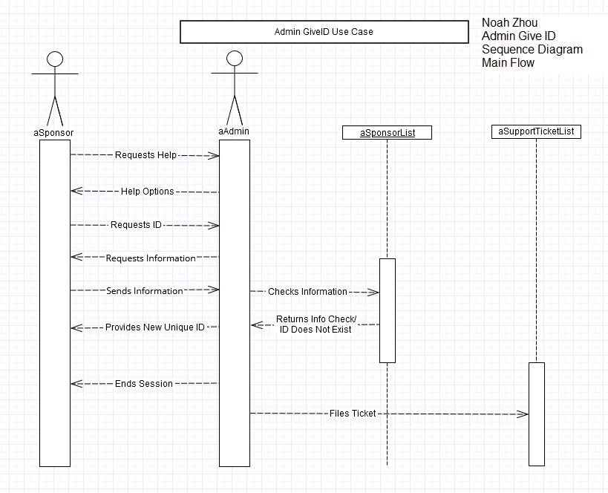

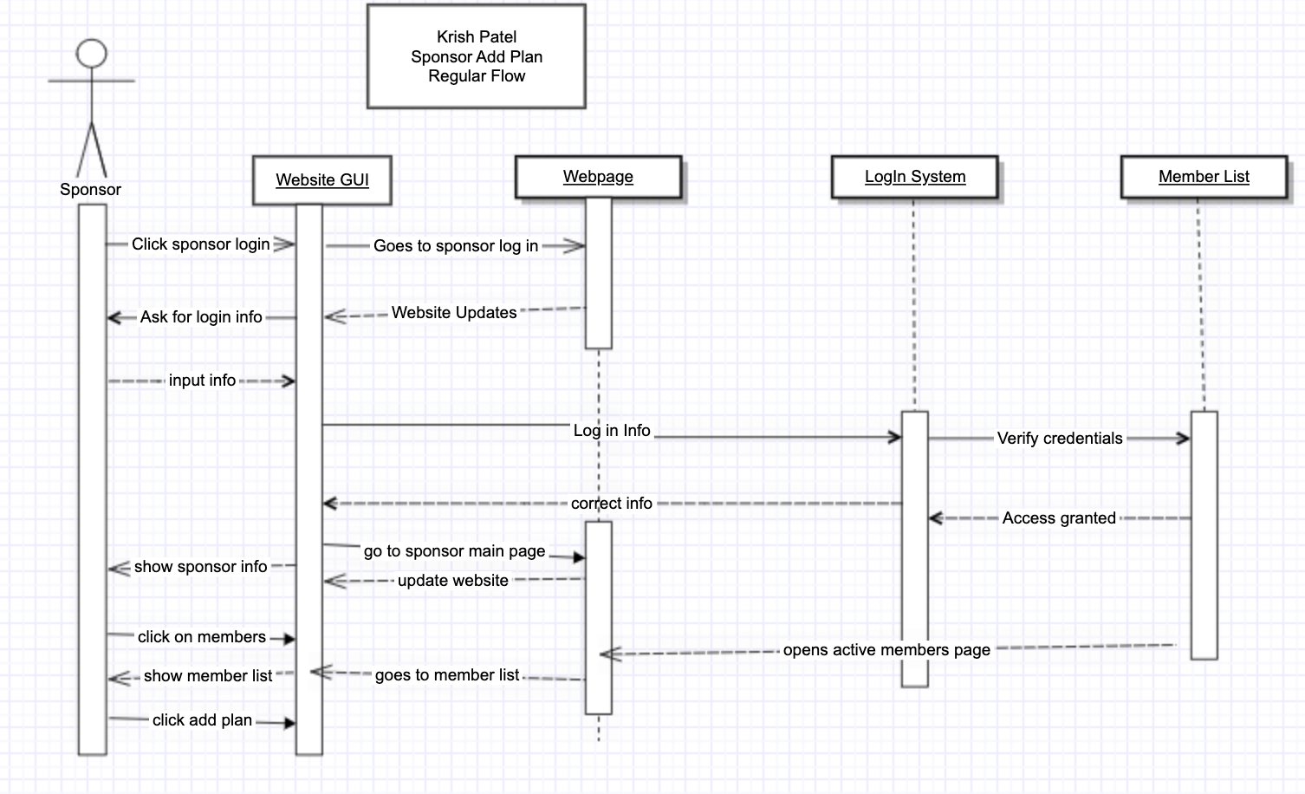

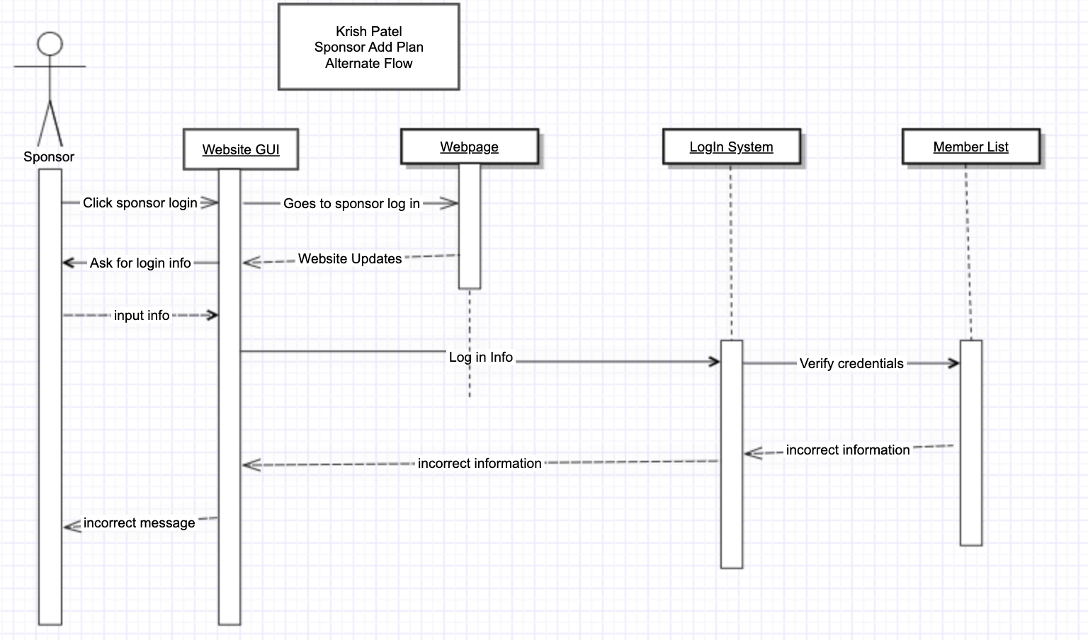

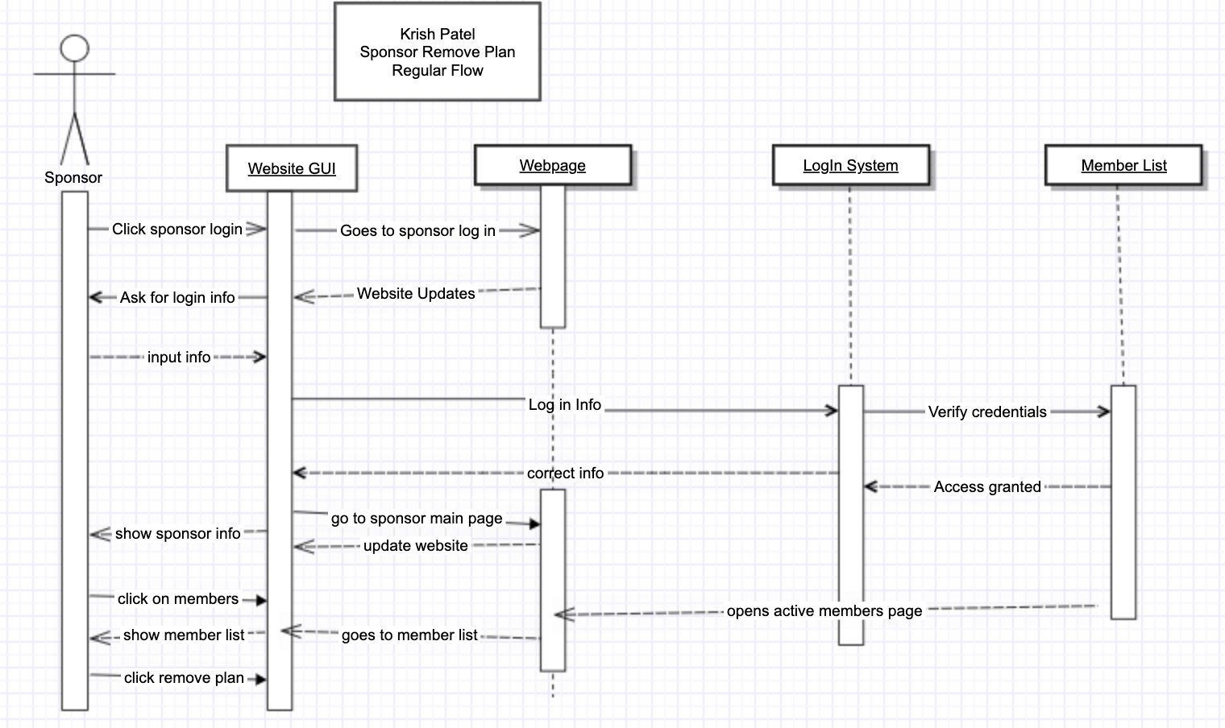

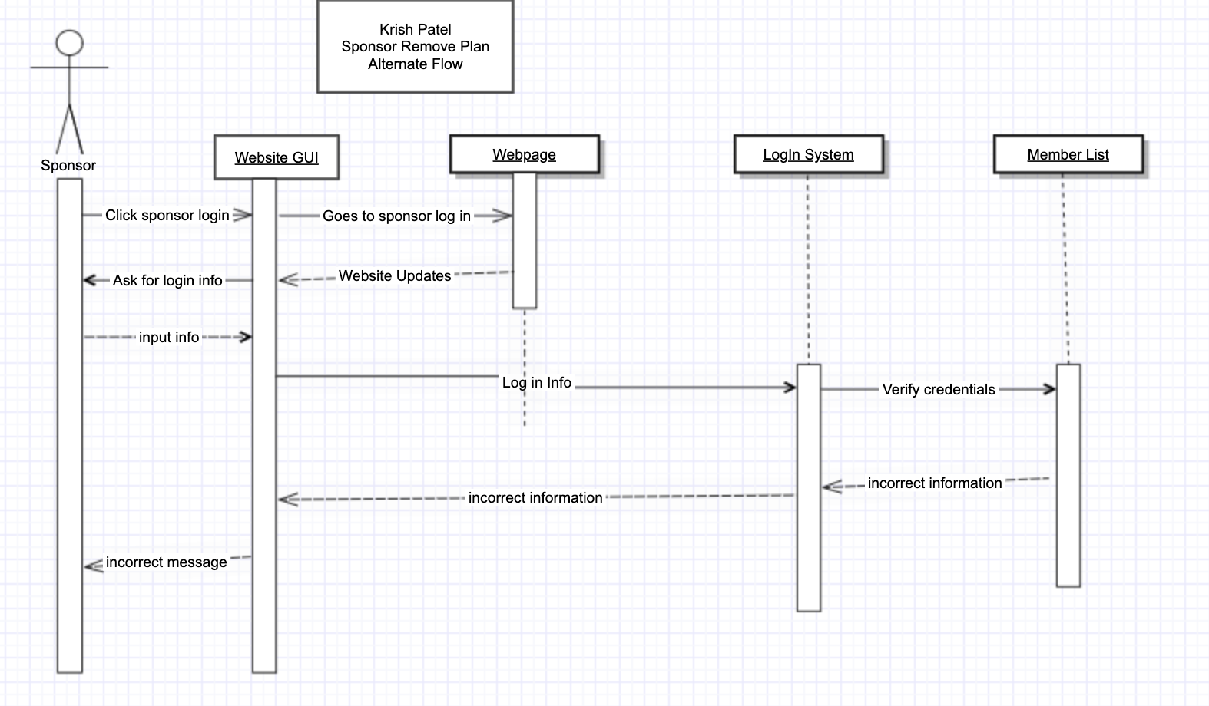

Brayden Lingelbach -

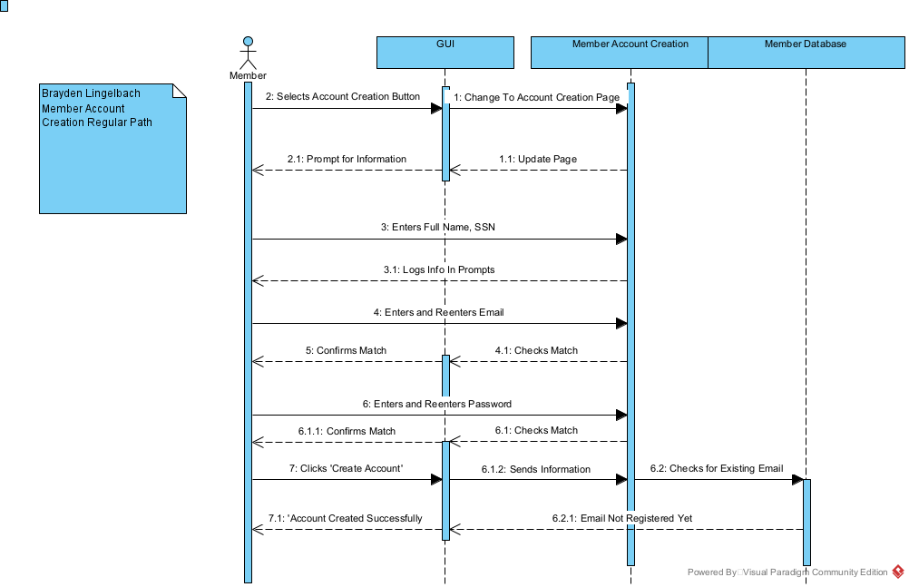

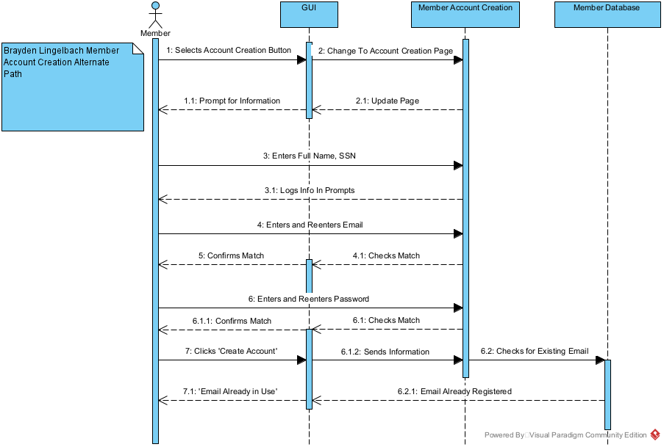

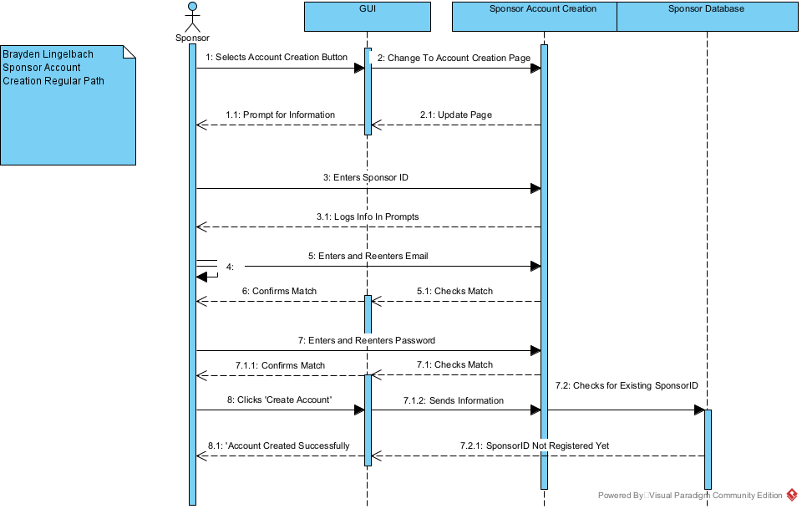

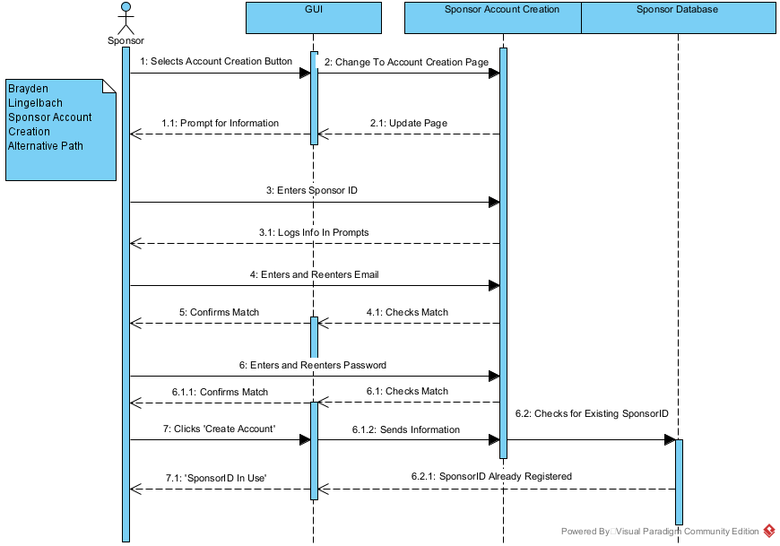

Gantt Chart

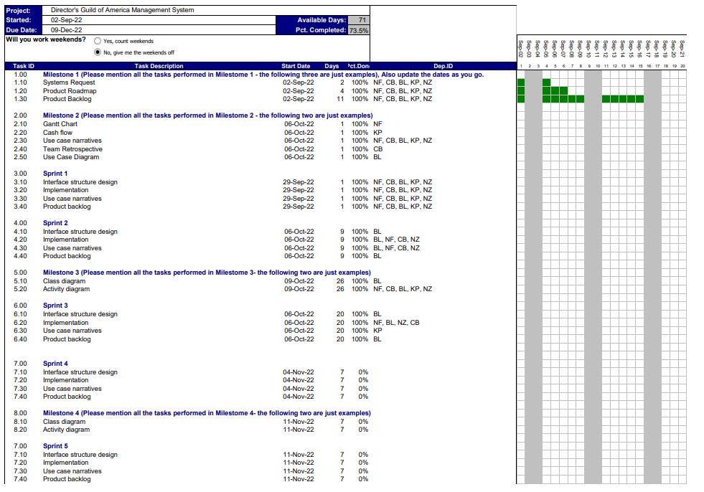

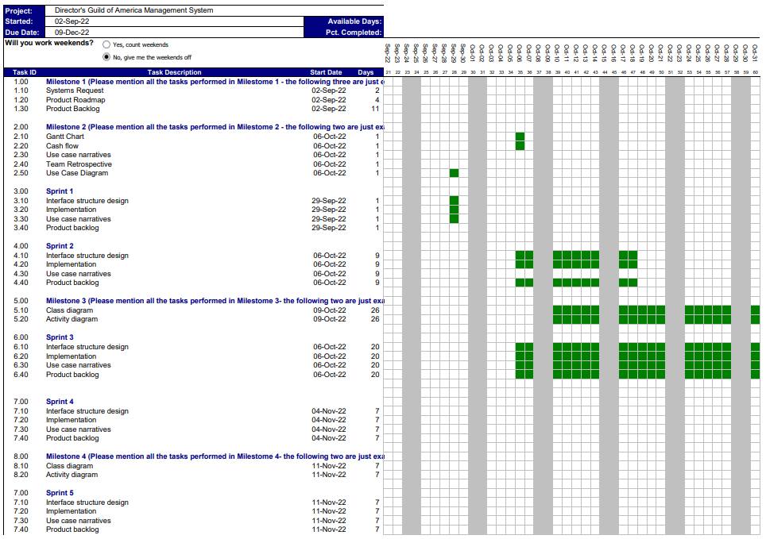

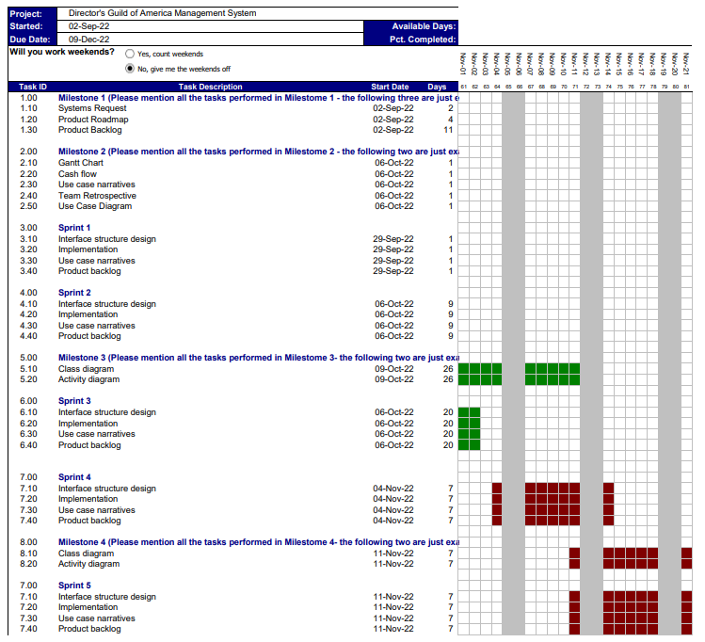

Team Retrospective

* Planning:
  + The team split up the work into 2 activity diagrams and 2 sequence diagrams along with other parts of milestone 3 to help with efficiency.
  + The team planned designated meetings outside of class time to address any questions
  + The team communicated their progression on their individual tasks throughout milestone 3 to make sure no one fell behind
  + The team designated Microsoft teams as the place for questions, and file uploads for milestone 3
* Monitoring:
  + By assigning everyone their task before the milestone was started efficiency increased substantially, and there were not as many questions.
  + Microsoft teams did not promote good communication due to lag but allowed everyone to congregate their parts of milestone 3 into a single folder.
  + Meetings were preferred to be held in person rather than online but meeting online allowed more leniency within the team's individual schedules.
* Evaluation:
  + The activity diagrams, and sequence diagrams were complete without issues appearing.
  + The Teams plan to split up the work ended up allowing the milestone 3 to be complete quickly due to everyone knowing what needed to be completed, and when.
  + Although splitting up work has proven to be beneficial to efficiency within the milestone it led to a breakdown of communication due to people being focused on their individual task.
* Plan of Action:
  + Further steps can be taken to ensure if someone is struggling that they have to outlet to voice their struggles without feeling pressured.
  + Further organization of documentation and charts would allow for easier implementation in future milestones.